Dear Parents –
It’s that time! Time for our students to put down the sunscreen and pick-up the books! Why not start their school year off with some love from home! This year, the Lancer Parent Partnership is happy to sponsor the “First Day of School Goodie Bag”. Send your SMHS student a message and some goodies to let them know how proud you are of them and wish them the best for a successful 2017-2018 school year!
How do you participate? It’s simple, fill out the message below and send a check for $15.00 payable to St. Mary’s High School - Attention LPP - 142 Laverack Ave., Lancaster, NY 14086. We will do the rest! Goodie bags and messages will be passed out the first day of school!
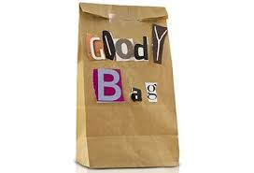

PLEASE return this form no later than August 14th!
Students Name: ______________________________________
Grade: _______
Message:
________________________________________________________________
________________________________________________________________
________________________________________________________________
________________________________________________________________
________________________________________________________________

Best of luck for a successful school year!

